**Stored Procedures Assignment**

1. Create a procedure that uses a cursor to generate the below report, which contains the first and last name of the customer that bought a Hrd. cloth, 1/4-in., 2x50. Use the tables: sales_co.CUSTOMER, sales_co.product, sales_co.line, and sales_co.invoice i

Query:

use db2; go declare

@first nvarchar(30),

@last nvarchar(30), @product1 nvarchar(30);

set @product1 = 'Hrd. cloth, 1/4-in., 2x50';

exec proc1 @first1 output, @last1 output, @product1;

print '=============================================';

print @first1 + ' ' + @last1 +Bought'+ @product1;

print'==================================';

Format you output as show on example document.

Code:

CREATE PROCEDURE proc1

(

@first nvarchar(30) output,

@last nvarchar(30) output,

@product nvarchar(30)

)

AS

DECLARE db_cursor CURSOR FOR

SELECT CUS_FNAME, CUS_LNAME, P_DESCRIPT FROM [sales_co].[LINE] a

JOIN [sales_co].[INVOICE] c ON c.INV_decimal = a.INV_decimal

JOIN [sales_co].[PRODUCT] b ON a.P_CODE = b.P_CODE

JOIN [sales_co].[CUSTOMER] d ON c.CUS_CODE = d.CUS_CODE

WHERE P_DESCRIPT = @product;

OPEN db_cursor

FETCH NEXT FROM db_cursor INTO @first, @last, @product

WHILE @@FETCH_STATUS = 0

BEGIN

SET @first = @first;

SET @last = @last;

FETCH NEXT FROM db_cursor INTO @first, @last, @product

END

CLOSE db_cursor

DEALLOCATE db_cursor

Results:

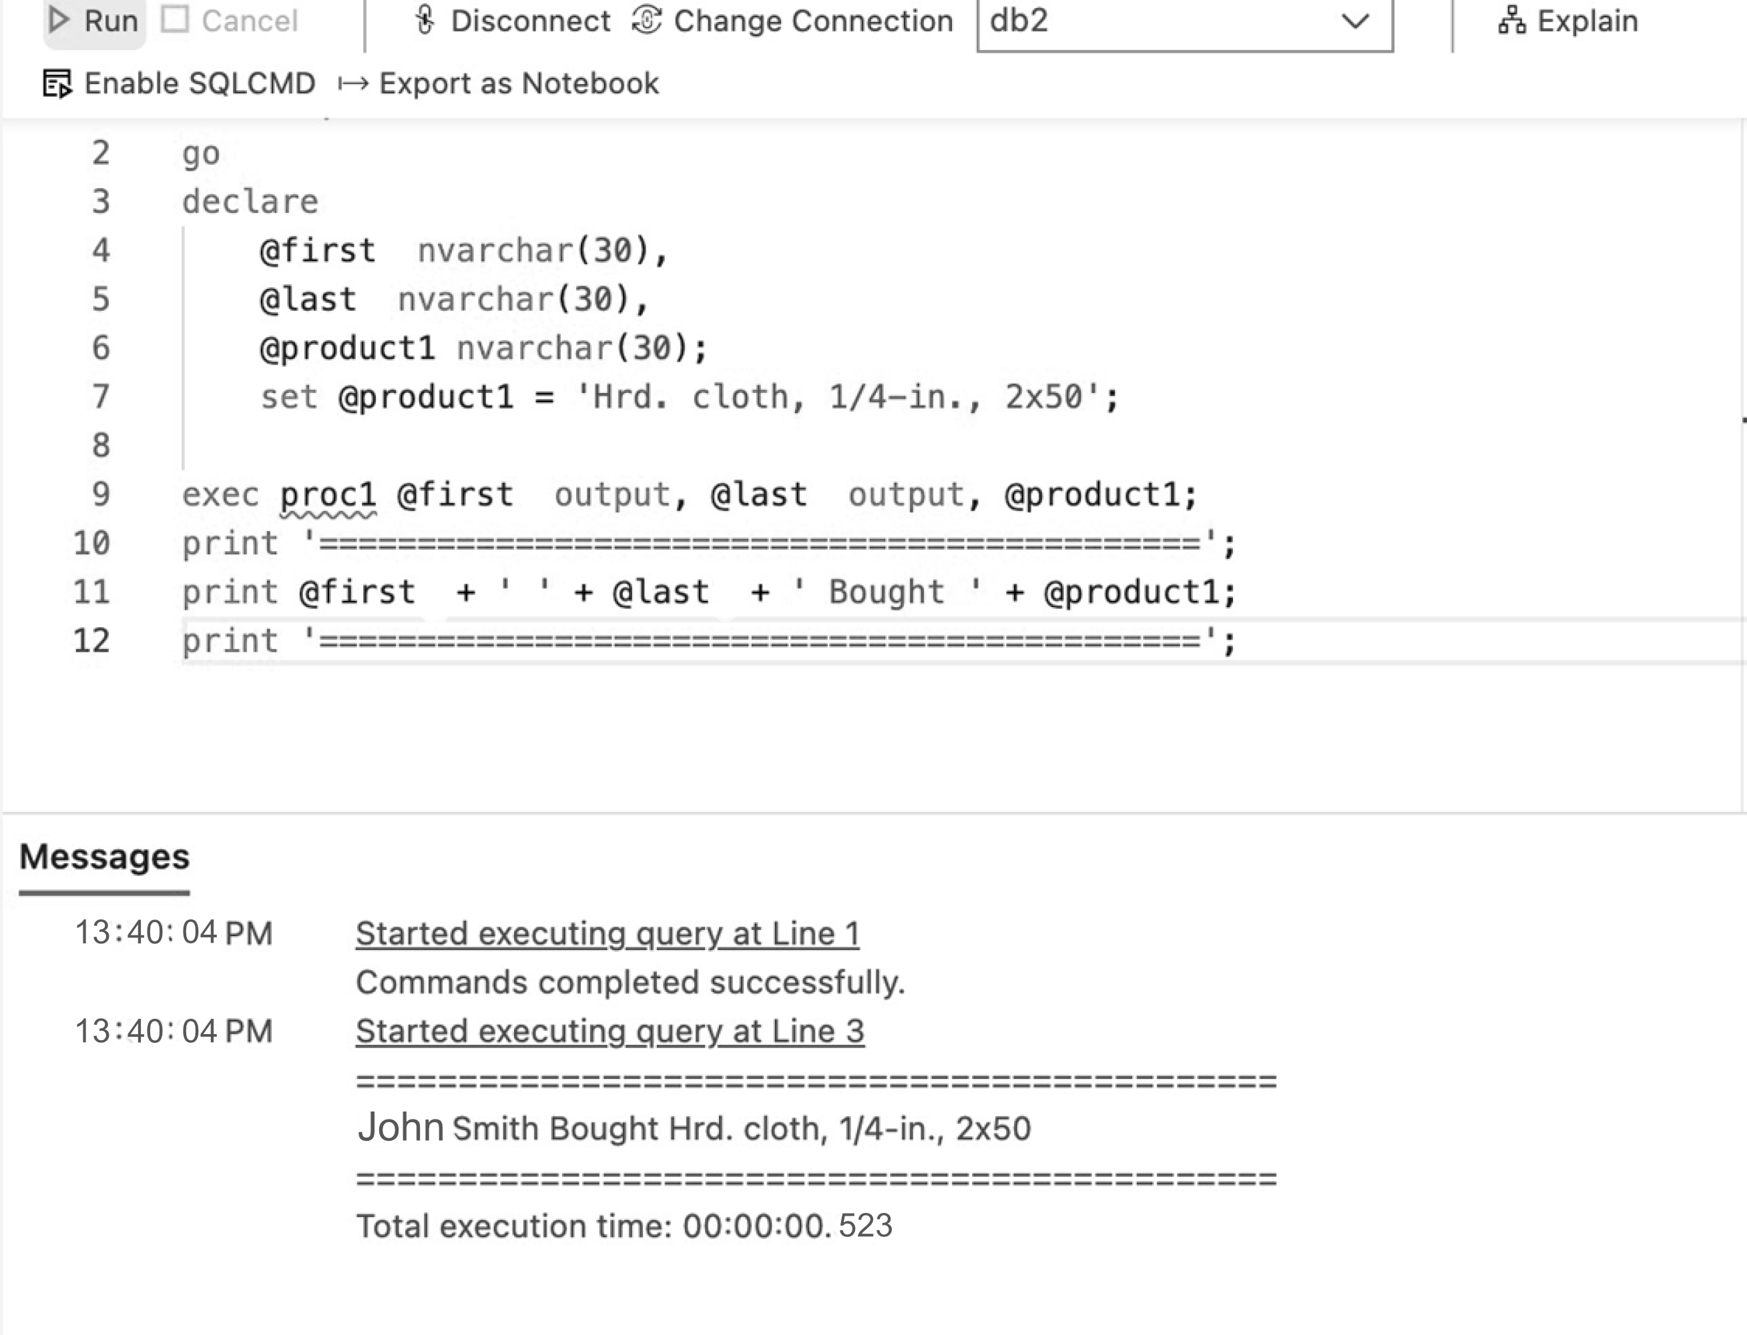

2. Create a procedure that removes your name from the table db2.college.students. If your name is not in the database use 'Amber' 'Howard'. If the your name or 'Amber' 'Howard' is not in the database, print out the name

+ ' is not in the database anymore'

Query:

AS

BEGIN

IF EXISTS (SELECT * FROM db2.College.Students WHERE LastName = @last1)

BEGIN

SET @last1 = 'Rotger'

IF EXISTS (SELECT * FROM db2.College.Students WHERE LastName = @last1)

BEGIN

DELETE FROM db2.College.Students WHERE LastName = @last1

PRINT @last1 + ' has been deleted';

END

ELSE

BEGIN

PRINT @last1 + ' is not in the database anymore.'

END

END

ELSE

BEGIN

PRINT @last1 + ' is not in the database anymore.'

END

END

Results:

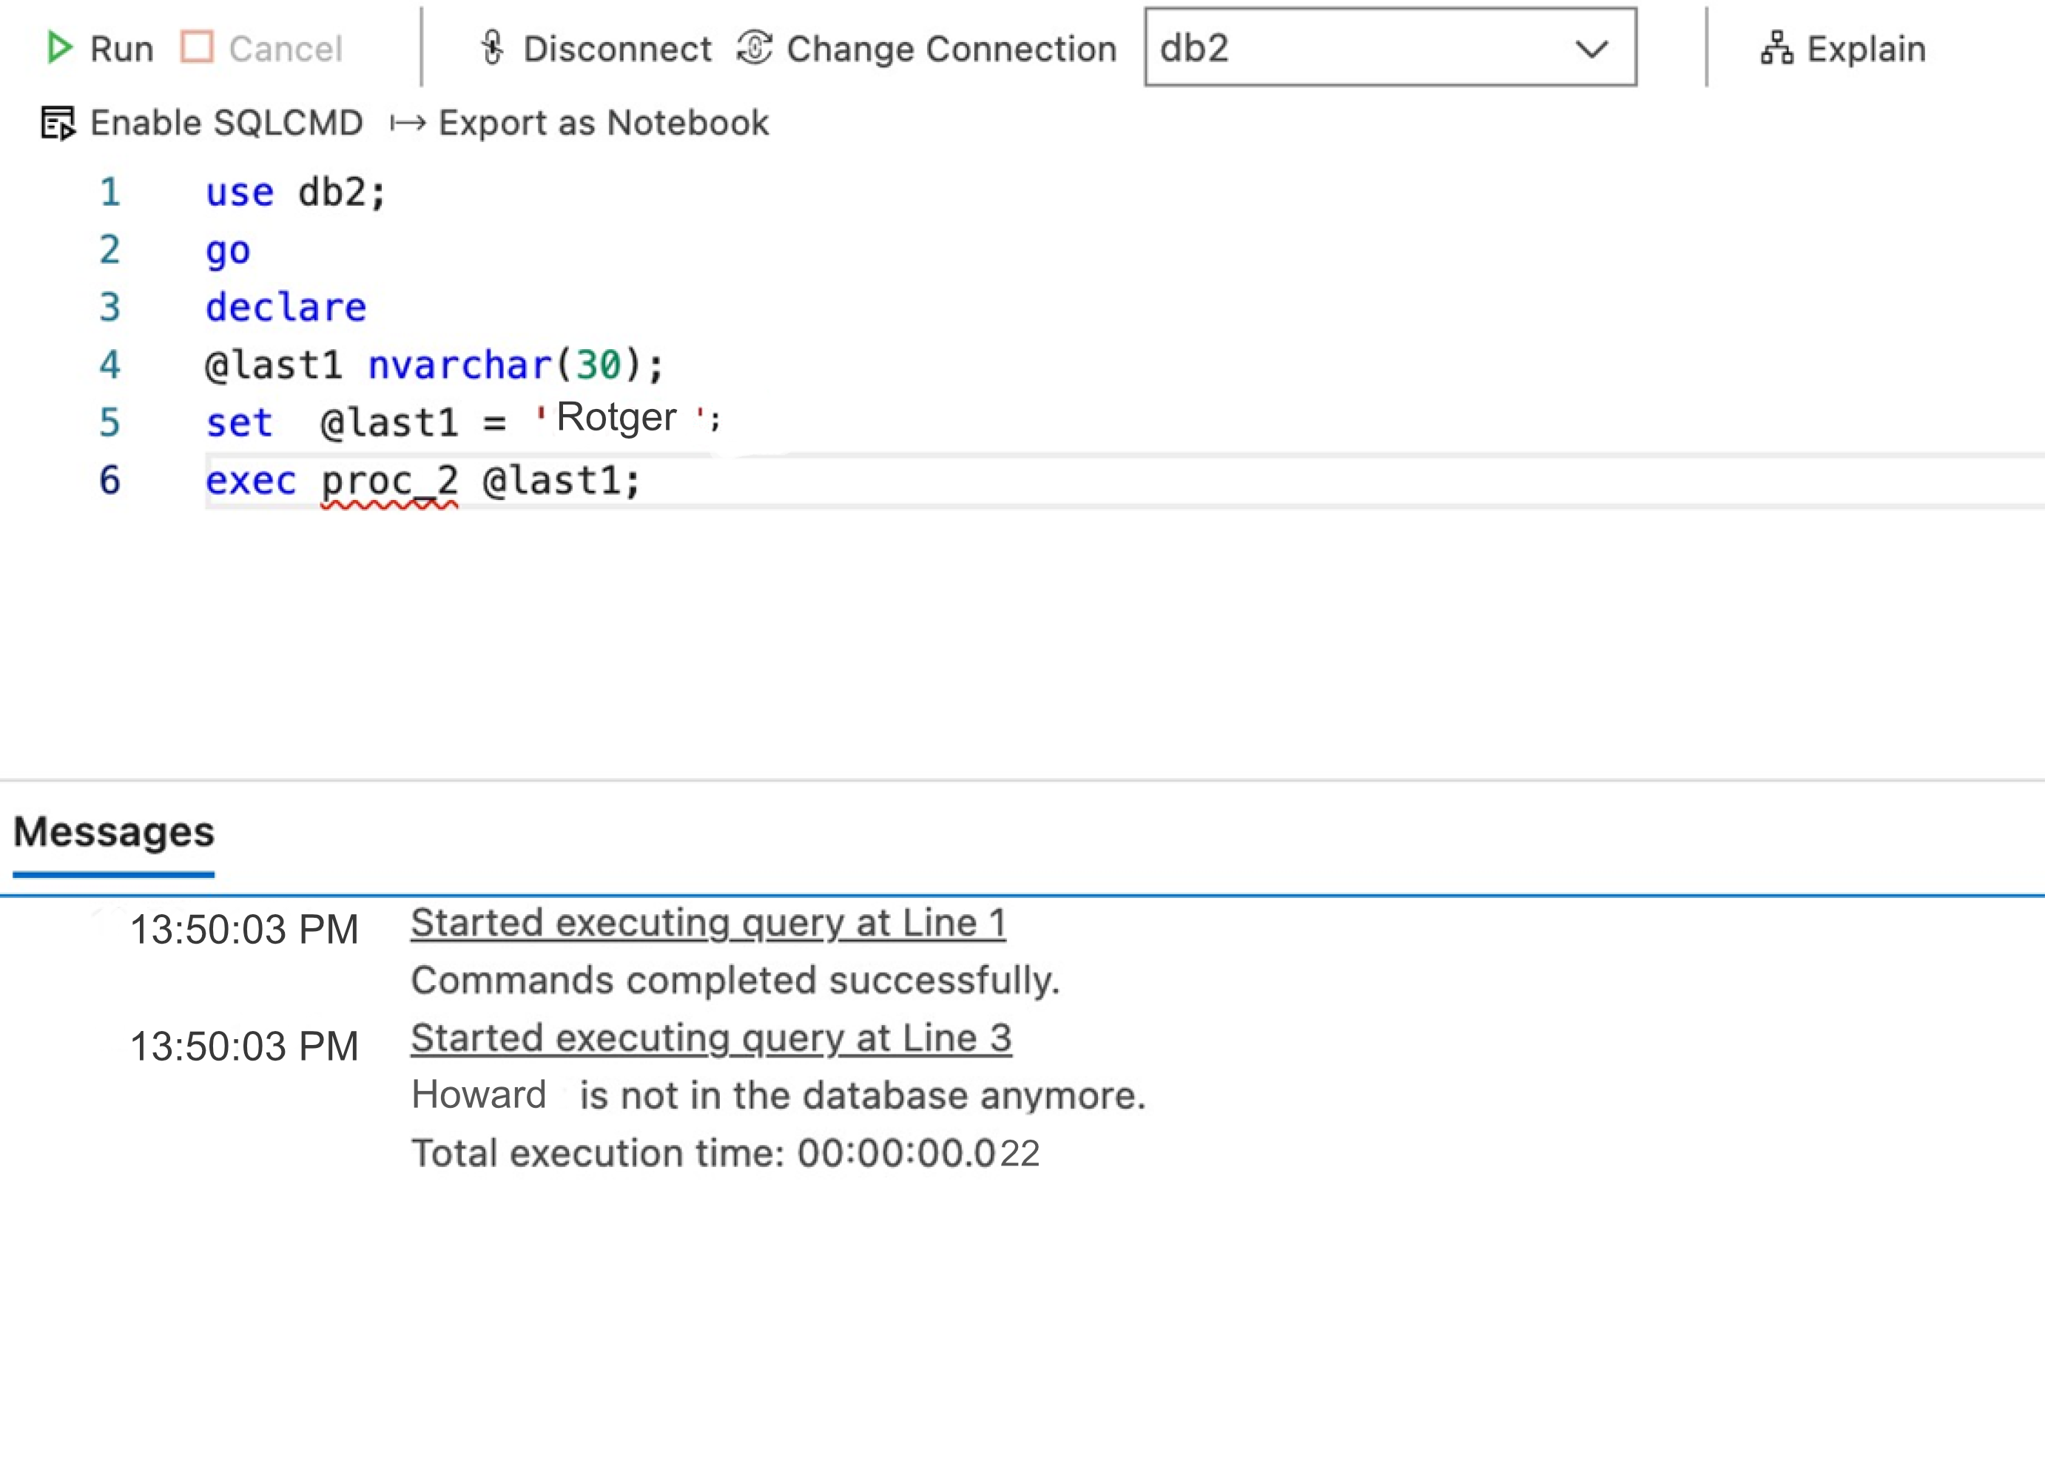

3. Use the db2 database and the MM schema. Create 2 procedures named MOVIE_RENTAL & MOVIE_RETURN. One procedure movie_rental has 4 parameters, 2 input (passed to procedure) and two output (passed out of the procedure). This procedure will take in the title of the movie and the last name of the person renting the movie. It will then populate the output variables with the movie_id and the member_id. The second procedure movie_return has 3 parameters, 2 input one output. movie_return will be executed by the script in the assignment receiving the title of the movie and the last name of the person renting the movie, calling the procedure movie_rental at the beginning of the procedure. Using the output of the procedure move_rental it will determine if the member has rented the movie, if they have rented the movie print out that the member has returned the movie and insert today's date for the check_in date

Query::

GO

CREATE PROC MOVIE_RENTAL

(

@LAST_NAME VARCHAR(50),

@MOVIE_TITLE VARCHAR(50),

@MOVIE_ID VARCHAR(50) OUTPUT,

@MEMBER_ID VARCHAR(50) OUTPUT

)

AS

SELECT @MEMBER_ID = member_id

FROM db2.MM.member

WHERE last = @LAST_NAME

SELECT @MOVIE_ID = movie_id

FROM db2.MM.movie

WHERE movie_title = @MOVIE_TITLE

GO

CREATE PROC MOVIE_RETURN

(

@LAST_NAME VARCHAR(50),

@MOVIE_TITLE VARCHAR(50),

@MESSAGE VARCHAR(200) OUTPUT

)

AS

BEGIN

DECLARE @MOVIE_ID VARCHAR(50), @MEMBER_ID VARCHAR(50)

EXEC MOVIE_RENTAL @LAST_NAME, @MOVIE_TITLE, @MOVIE_ID OUTPUT, @MEMBER_ID OUTPUT

SET @MESSAGE = @LAST_NAME + ' did not return the movie ' + @MOVIE_TITLE

END

Results:

